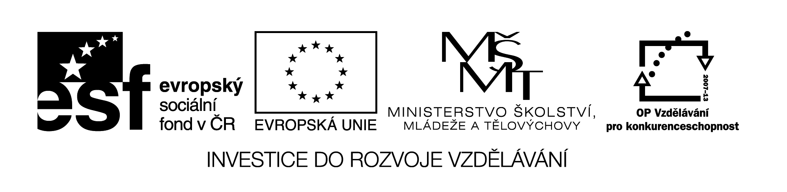

TO BE GOING TO
EXPLANATION :
We use to be going to to express our future
a) PLANS : I am going to travel to Thailand in summer. or We are going to go to the cinema on Friday.
b) INTENTIONS : He is not going to marry her. or They are going to walk in the mountains.
c) PREDICTIONS : She is going to have a baby in May. or Look at the sky! It is going to rain.
EXERCISES :
1. Write sentences and questions using be going to.
1. Peter/not come/on the school trip/next Thursday.
___________________________________________
2. Her mum/not book/ a holiday/ in Mallorca.
_____________________________________
3. I/not get on/that busy tram.
_____________________________________
4. They/stay/in a luxury hotel/in Paris ?
_____________________________________
5. What time/you/board/the plane ?
_____________________________________
2. Complete the sentences using be going to.
1. What ___________________ while they are on a trip in the Alps? (they/do)
2. We _____________________ any souvenirs when we are abroad.(not buy)

Vzdělávací materiál byl vytvořen v rámci projektu
Inovace a zkvalitnění výuky na Slovanském gymnáziu
CZ.1.07/1.5.00/34.1088

3. ________________________ to fly to London or ____________________
by bus? (you/go) ?
4. What _____________________________ in the city? (she/see)
5. Who ___________________________ abroad with ? (she/travel)

3. Complete the text with the correct form of be going to and the verbs.
This winter we _____________________ (not go) abroad on holiday. We _______________________ (spend) a few days with our grandparents. My grandma is an excellent cook and she _____________________ (bake) us a special Christmas cake with lots of fruit. Maybe we _________________ (go skiing) somewhere in the mountains if there is enough snow. My dad _________________ ( not drive) there because he doesn´t like driving in winter. That´s why we _________________ ( go) there by train. My mum _________________ (make) food and she ______________ ( pack) our things in the evening. My sister ________________ (not travel) with us since she _______________________( have) a baby very soon. One thing I know for sure. I __________________ ( not do) anything for school !

ŘEŠENÍ
TO BE GOING TO
EXERCISES :
1. Write sentences and questions using be going to.
1. Peter/not come/on the school trip/next Thursday.
Peter´s not coming on the school trip next Thursday.
2. Her mum/not book/ a holiday/ in Mallorca.
Her mum isn´t going to book a holiday in Mallorca.
3. I/not get on/that busy tram.
I´m not going to get on that busy tram.
4. They/stay/in a luxury hotel/in Paris ?
Are they going to stay in a luxury hotel in Paris?
5. What time/you/board/the plane ?
What time are you going to board the plane?
2. Complete the sentences using be going to.
1. What are they going to do while they are on a trip in the Alps? (they/do)
2. We aren´t going to buy any souvenirs when we are abroad . (not buy)
3. Are you going to fly to London or are you going to go by bus? (you/go) ?
4. What is she going to see in the city? (she/see)
5. Who is she going to travel abroad with ? (she/travel)
3. Complete the text with the correct form of be going to and the verbs.
This winter we aren´t going to go abroad on holiday. We are going to spend a few days with our grandparents. My grandma is an excellent cook and she is going to bake us a special Christmas cake with lots of fruit. Maybe we are going to go skiing somewhere in the mountains if there is enough snow. My dad isn´t going to drive there because he doesn´t like driving in winter. That´s why we are going to go there by train. My mum is going to make food and she is going to pack our things in the evening. My sister isn´t going to travel with us since she is going to have a baby very soon. One thing I know for sure. I am not going to do anything for school !

