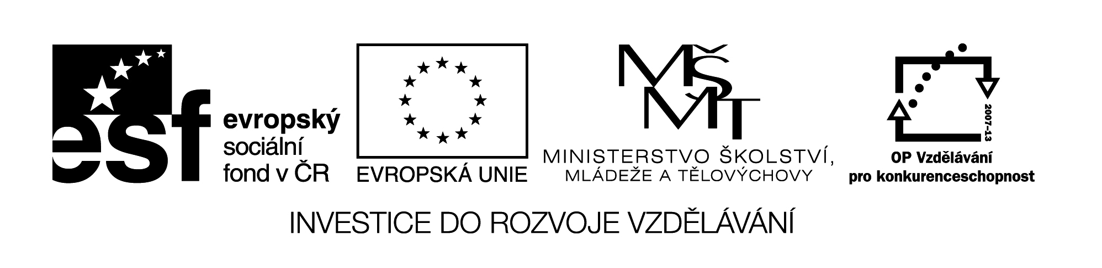

Complete the text with the correct tense.
J. K. ROWLING
She _______________ (be born) in 1965 near Bristol, in England. She_______________ (grow up) and ____________ (go) to school there. She __________ (get) a degree in French and Classics and _____________ (work) at Amnesty International in London. Then she ____________ (move) to Portugal, where she ______________ (teach) English, ___________ (get married) and _____________ (give) birth to her first child, called Jessica, in 1993. But her first marriage __________ (end) in divorce and she ___________ (move) to Edinburgh in Scotland. She _____________ (be) married since 2001 when she ____________ (marry) Dr Neil Murray who is a doctor. The wedding ceremony _____________ (take) place in the library and there ___________ (be) only 15 guests. They _________ (have) two children, a son and a daughter, and __________(live) in Edinburgh, Scotland.
She _____________(become) famous as an author of books about a young boy attending a school of wizardry called Harry Potter. The idea ___________ (come) into her mind while she _________ (be) on a four-hour-delayed train trip from Manchester to London. While she _________________ (write) Harry Potter books, her mother _________ (die) and it also affected her writing. In 1995, Rowling ____________ (finish) her manuscript for Harry Potter and the Philosopher´s Stone on an old manual typewriter. Since then she _______________ (publish) 6 sequels—the last, Harry Potter and the Deathly Hallows, released in 2007, ___________ (break) record as the fastest-selling book of all time. It ____________ (sell) 11 million copies in the first day in the United Kingdom and the United States. She ________________ (receive) honorary degrees from six universities and more than ten book awards. She ______________ (write) ten books for children and two books for adults so far and ____________ (become) one of the richest women in the world.
Vzdělávací materiál byl vytvořen v rámci projektu
Inovace a zkvalitnění výuky na Slovanském gymnáziu
CZ.1.07/1.5.00/34.1088

J.K.ROWLING
She was born in 1965 near Bristol, in England. She grew up and went to school there. She got a degree in French and Classics and worked at Amnesty International in London. Then she moved to Portugal, where she taught English, got married and gave birth to her first child, called Jessica, in 1993. But her first marriage ended in divorce and she moved to Edinburgh in Scotland. She has been married since 2001 when she married Dr Neil Murray who is a doctor. The wedding ceremony took place in the library and there were only 15 guests. They have two children, a son and a daughter, and live in Edinburgh, Scotland.
She has become famous as an author of books about a young boy attending a school of wizardry. The idea came into her mind while she was on a four-hour-delayed train trip from Manchester to London. While she was writing Harry Potter books, her mother died and it also affected her writing. In 1995, Rowling finished her manuscript for Harry Potter and the Philosopher´s Stone on an old manual typewriter. Since then she has published 6 sequels—the last, Harry Potter and the Deathly Hallows, released in 2007, broke record as the fastest-selling book of all time. It sold 11 million copies in the first day in the United Kingdom and the United States.She has received honorary degrees from six university and more than ten book awards. She has written ten books for children and two books for adults so far and has become one of the richest women in the world.

